KultureHire

Create Database and import dataset

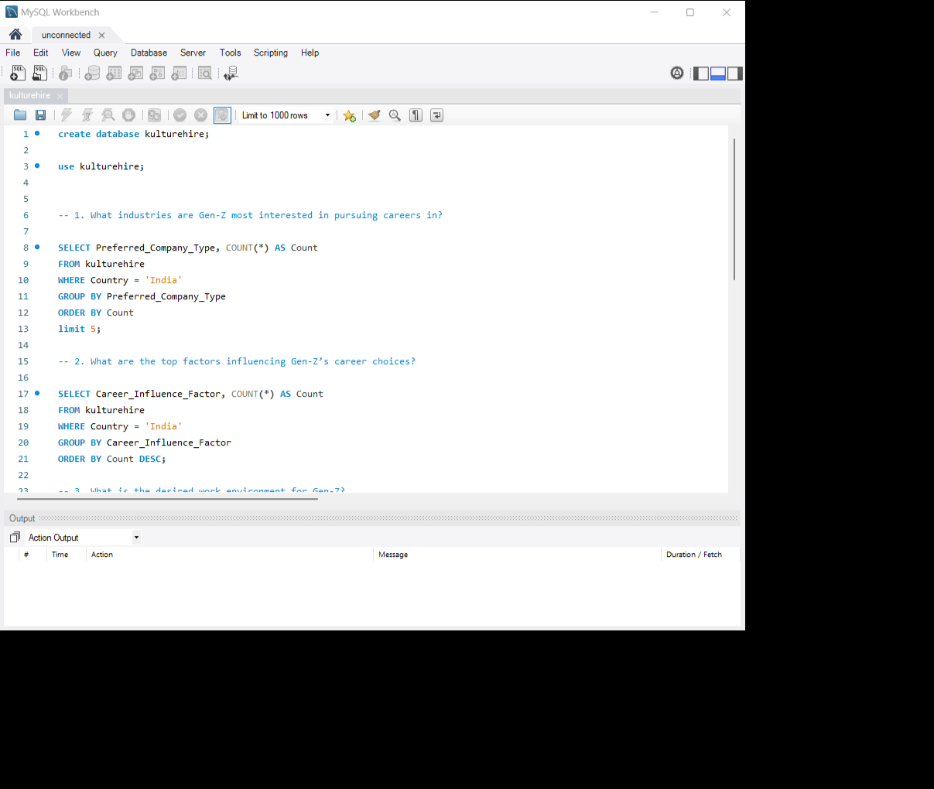

1. What industries are Gen-Z most interested in pursuing careers in?

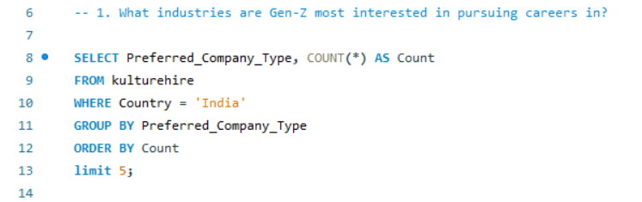

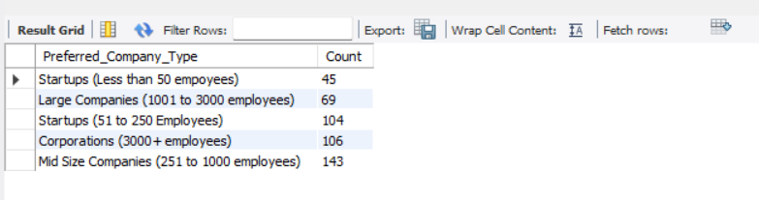

1. What are the top factors influencing Gen-Z’s career choices?

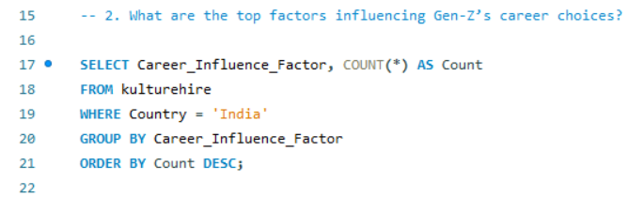

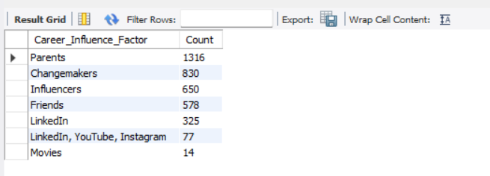

1. What is the desired work environment for Gen-Z?

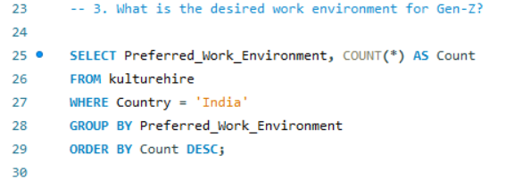

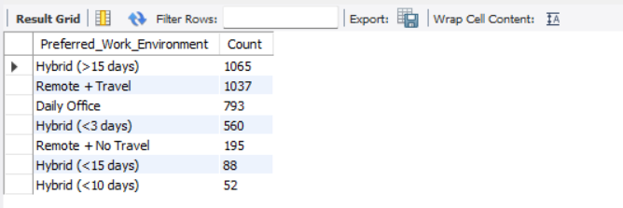

1. How do financial goals, such as salary, impact career aspirations among Gen-Z?

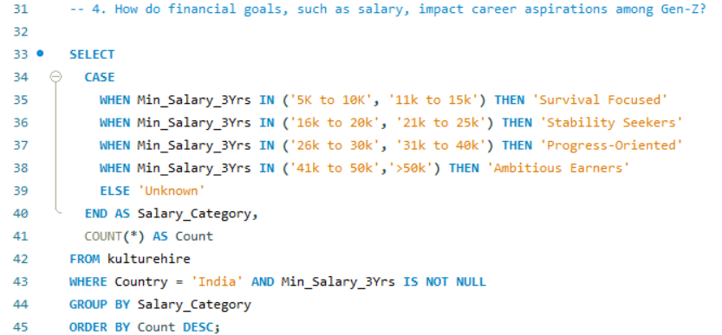



1. What role do personal values and social impact play in career choices for Gen-Z?

